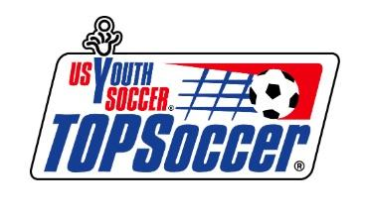 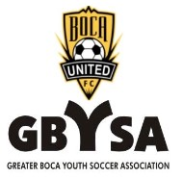

What Is TOPSoccer?

The TOPSoccer Program TOPSoccer is a safe and dependable soccer outreach program of U.S. Youth Soccer and is offered by more than 25 soccer clubs throughout the state of Florida, including GBYSA. TOPSoccer (The Outreach Program for Soccer) is a community-based youth sports program for children with special needs starting at 4 years old.

As a part of TOPSoccer we foster the ability for any special needs child with, but not limited to, autism spectrum disorder, developmental delays, down syndrome, muscular dystrophy, cerebral palsy and attention deficit disorder. The program is designed to bring the opportunity of learning and playing soccer to any boy or girl, who has any type of special needs. We help encourage and promote special needs children to get up off the sidelines and right into the game of soccer.

TOPSoccer programs could not operate without the assistance of our volunteers/buddies, who donate their time, energy, care and respect to our players. Our buddies come from local schools starting in eighth grade thru college. In addition, to the satisfaction of helping our players learn the game, our buddies receive community service hours and have the opportunity to compete for GBYSA awards and scholarships.

As a part of the TOPSoccer community, we continue to follow US Youth Soccer's model designed to enrich the lives of children with physical and/or mental disabilities. For the duration of our program, we will continue to provide special needs’ athletes with fitness opportunities, social skills, the chance to learn teamwork, perseverance and self-confidence. Our goal is to enable the thousands of young athletes with disabilities to become valued and successful members of the US Youth Soccer family.